|  |
| --- |
| Circle Language Spec: Commands |

## Beware of Active Command References in Commands in a Diagram

The rule, that advises you to beware of what you are doing, when you are using an active command reference inside a command, was already covered conceptually in the article *Beware of Active Command References in Commands*. The current article further explains it using diagrams.

You have to be aware, that when you use an active command reference, the active command reference may already have been executed.

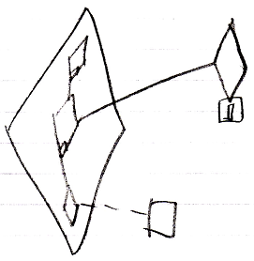

Or that you may be *waiting* on an external execution to finished.

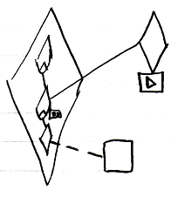

If the external execution won’t finish, then the referring procedure is stuck.

If the external command object is an inactive command object, it will never execute, and the command will truly be stuck. A warning should be generated then.

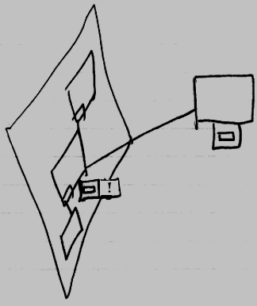

It is *not* the rule, to beware of any active command reference. It is the rule to just always beware of them in a *parent command*. An *object* can contain an active command reference, in order to for instance allow a user to carry around a reference to an active command, executing on a site somewhere.

